**Name :** Dhavalkumar Vijaykumar Patel

**Subject :** Essential of Cyber Security and Cyber Waefare

**Class :** M.Sc Cyber Security

**Semester :** 1

**Lab 5 :**

1. pwdump3 utility to obtain password hashes

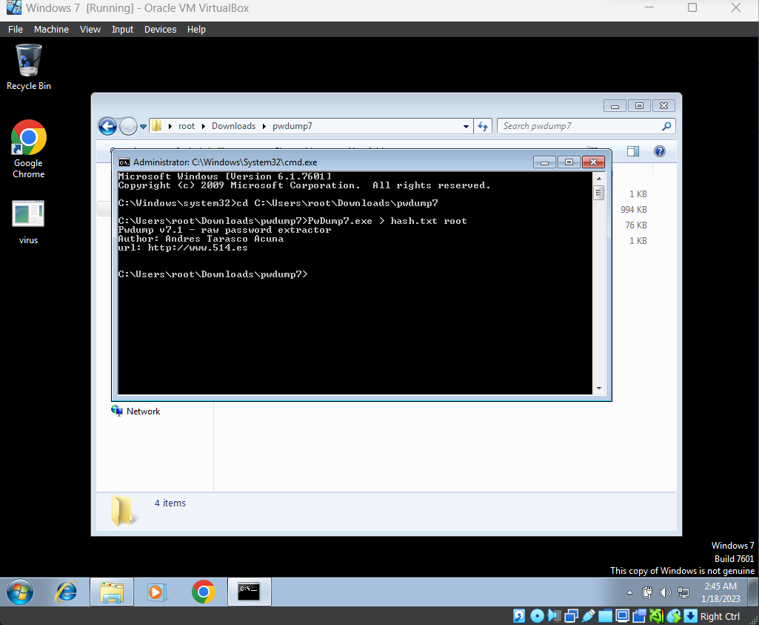

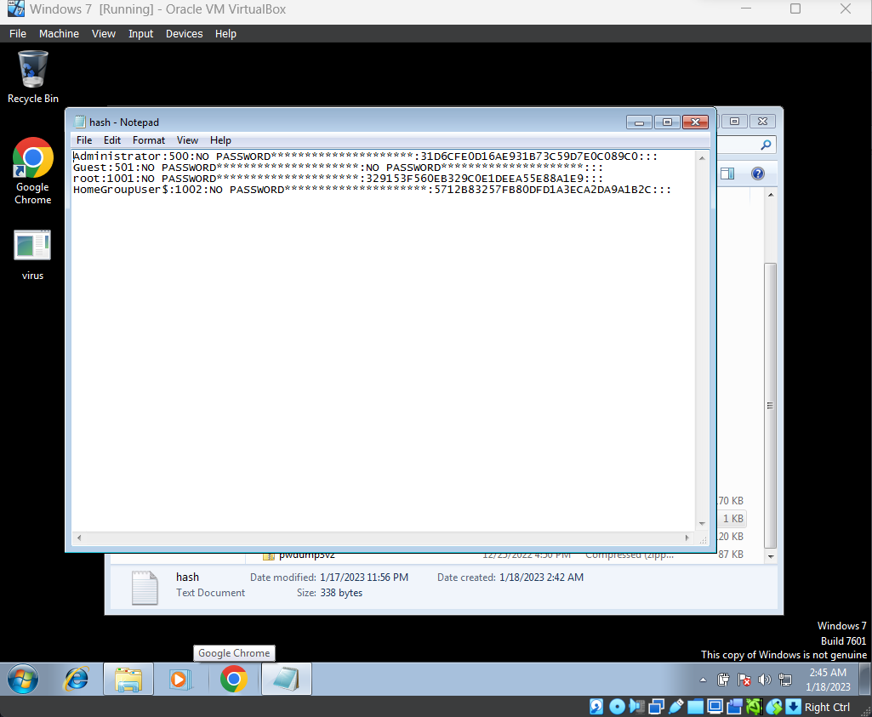

1. John the Ripper password cracking utility

**john.exe --format=nt --show hash.txt**

Use this command to crack the password hash of the file

